Jennifer Stegina

12 September 2019

CIS 250

**Unit 3 Graded Exercise 3**

The following questions come from the Check your understanding examples of each section of chapter 9 & 10 in your textbook.

After you are finished, please submit the Microsoft Word file that contains screenshots of the SQL script and the resulting tables. Your document should be named **U3_GradedExercise3_Lastname.docx**.

(9-3) Question 1:

The following select statement lists all the employees hired before January 1, 2000 and shows their credit limits. Modify this statement to add $10.00 to their credit limits.

This change in the amount of the credit limits shows up in this one result table, but does not affect the data in the underlying table.

select *employee_id,*

*first_name,*

*last_name,*

*credit_limit*

from *l_employees*

order *by employee_id;*

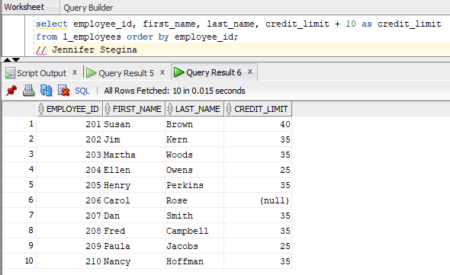

(9-4) Question 2:

From the *l_employees* table list the employee ID, first name, last name, and new credit limit (which is *credit_limit* + 10.00) for all employees whose new credit limit is above $20.00. Sort the rows by the new credit limit.

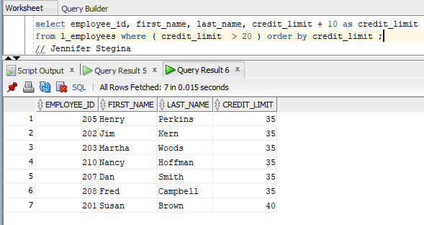

(9-10) Question 3:

List the employee ID and the names of all the employees. Write the names like “Brown, S.” with the last name capitalized, then a comma and a space, then the first initial capitalized followed by a period.

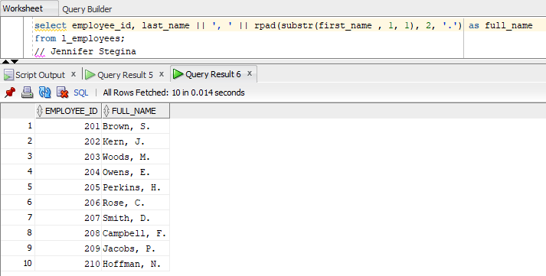

(9-11) Question 4:

Table *sec0911_names* contains names of people in the format “Brown, Susan V.” Create a new view in which you have separated the first name, middle initial, and last name into separate columns. Hint: This might be easier if you do it in a series of steps.

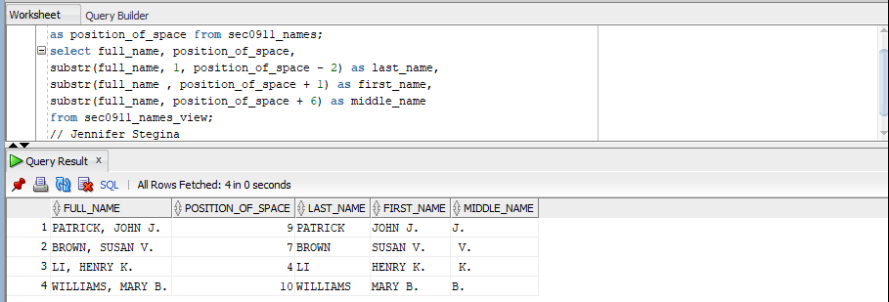

(9-12) Question 5:

Table *sec0912_phone_numbers* contains phone numbers in the format “(415) 627-1445” These numbers do not all begin in the first column. Create a new view with two columns in which you have separated the area code from the rest of the phone number.

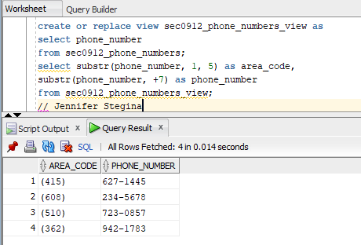

(10-4) Question 6:

The following select statements show all the numbers from 0 to 99. One of the statements sorts these numbers in numeric order, the others sort the numbers in alphabetic order. Run these queries. Can you see the difference in the order of the numbers?

select *n* as *numeric_order* from numbers_0_to_99 order by *n*;

select *to_char*(n) as *alphabetic_order* from *numbers_0_to_99* *order* by *to_char*(n);

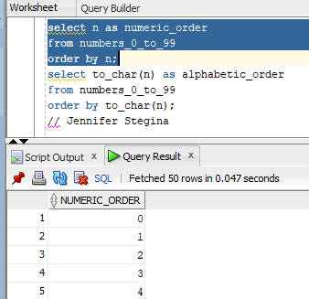

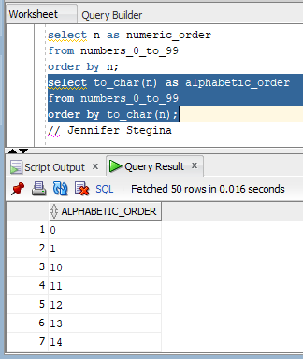

(10-5) Question 7:

Find and read the documentation for the *replace* function. First use the Master Index in the Oracle documentation, as that will probably give you the best result. Then try using the Search facility.

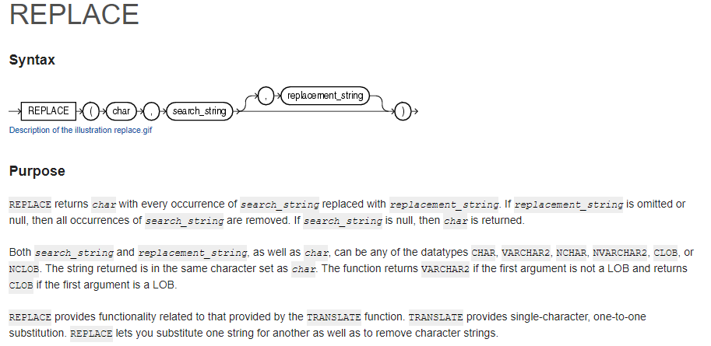

(10-6) Question 8:

Find and read the documentation for the *string* function.

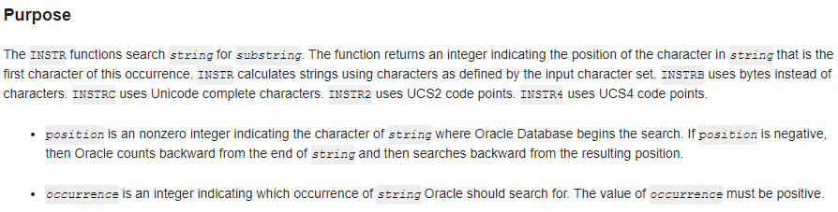

(10-7) Question 9:

Find the list of all the text functions. See if you can understand most of them.

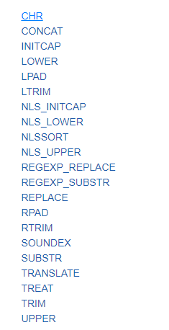

(10-8) Question 10:

Create a view of the multiples of 7 between 700 and 900.

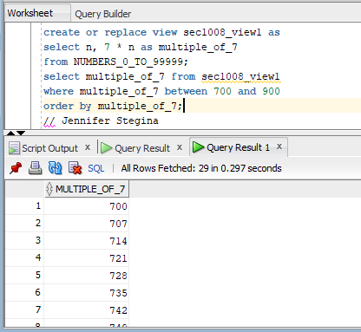

(10-10) Question 11:

Create a calendar showing all the days of the current month.

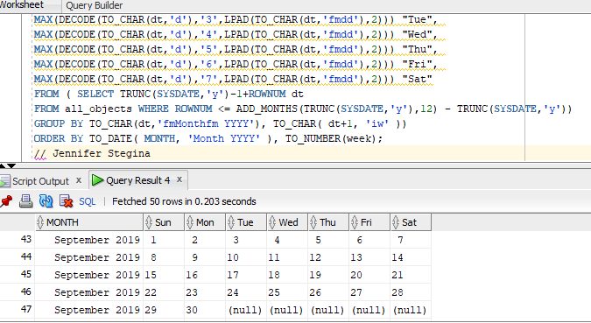

(10-12) Question 12:

Create a table showing several significant dates in your life. Have a date field and a text field that says what happened on that date. Then write a select statement that shows how many days have passed since that time.

